**CHEONG Soo Pieng (1917-1983)**

Cheong Soo Pieng was a Chinese born artist who became well known for his contributions to Singapore modern art. In Nanyang, Soo Pieng’s Chinese art training was integrated with the lush tropical landscape and the arresting allure of local communal practices. Soo Pieng was part of a group of artists who visited Bali, Indonesia in 1952 in search of the ‘Nanyang Style’ (Southeast Asian themes visualised with Western art techniques). The resulting imagery in the works created by the artists was exhibited in Singapore the following year in the lauded exhibition, *Four Artists to Bali*. The success of the display provided encouragement for the artists, which spurred them to further develop their particular genre of art. For Soo Pieng, his artistic excursions were not confined to Singapore. He also travelled to Sarawak, Borneo in 1959 and resided in Europe from 1961 to 1963, where he held solo and groups shows and where he also dabbled with abstraction in his works. Yet, Soo Pieng is recognised for his development of distinctive figural types known as elongated figures, that is female bodies with elongated limbs. The figural types he developed in the 1950s were reassessed and reworked in the 1970s. These later works reflected matured handling and refinement, demonstrating his personal stylisation of the subject matter.

Cheong trained at the Xiamen Academy of Fine Arts and Xinhua Academy of Fine Arts, Shanghai in Chinese and Western art. The confluence of Eastern and Western methodologies and incorporation of new ideologies influenced his later artistic development.

Cheong arrived in Singapore after World War II, where he felt impelled to migrate as a result of the Sino-Japanese war and the subsequent civil unrest in China. At the request of Lim Hak Tai—his teacher in Xiamen and the first principal of the Nanyang Academy of Fine Arts (NAFA), Singapore—Soo Pieng began teaching at NAFA where he became highly influential during the period of his tenure there (1947-1961). Many established artists in Singapore and Malaysia today were taught and inspired by the dynamism and creative vision of Cheong. After many years of teaching, he devoted his time to being a full time artist.

As an artist, Cheong did not confine himself to a single medium. In addition to working with paint, he produced numerous works of sculpture and metal relief at different stages in his career. Local and foreign collectors alike sought after his works. Notable collectors included Michael Sullivan (art historian and collector of Chinese art), Loke Wan Tho (cinema magnate), and Frank Sullivan (press secretary of the 1st Prime Minister of Malaysia and art collector). In 1962 Soo Pieng received the Meritorious Public Service Medal.

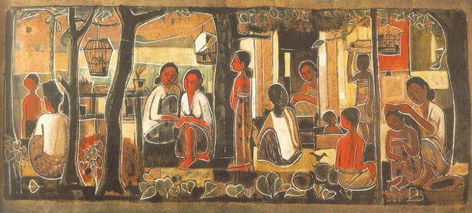

Cheong Soo Pieng, *Tropical Life*, 1959, Chinese ink and gouche on rice paper, 43.6 x 92 cm, National Visual Art Gallery, Malaysia.

**References and Further Reading**

---- (2013) *SOO PIENG*. Singapore: Nanyang Academy of Fine Arts.

Piyadasa R. and Sabapathy, T. K. (1979) *Pameran retrospektif pelukis-peukis Nanyang*. Kuala Lumpur: Muzium Seni Negara.

Yeo, Wei Wei. ed (2010) *Cheong Soo Pieng: Bridging Worlds*. Singapore: The National Art Gallery, Singapore.